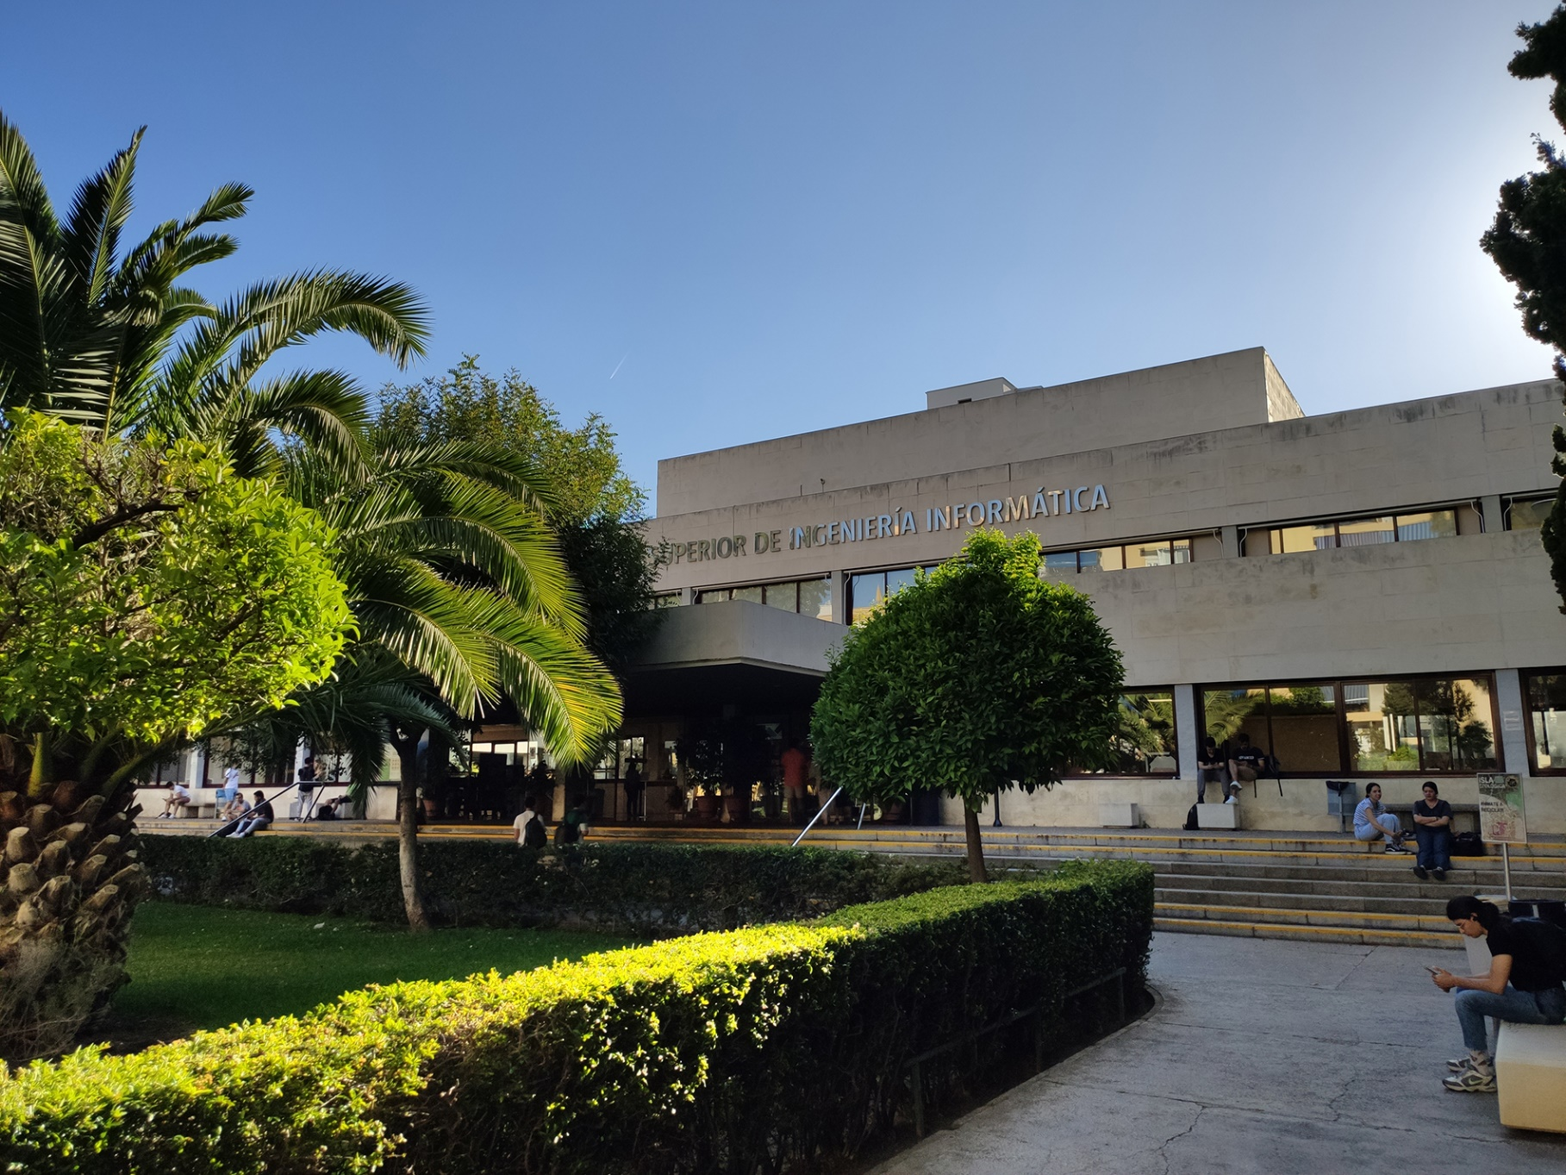

|  |
| --- |
| Analysis Report |
| Members:  Ismael Ruiz Jurado  (ismruijur@alum.us.es) |
| 17-02-2023  Group: C1.02.10  Repository: https://github.com/jescarcon/Acme-L3-D01-23.1 |



Table of Contents

Executive Summary 3

Version History 4

Introduction 5

Contents 6

Conclusions 7

Bibliography 8

# Executive Summary

In this report you will see my analysis of the requirements for the Student #4 that need some interpretation.

# Version History

|  |  |  |
| --- | --- | --- |
| Version | Date | Description of changes |
| V1.0 | 17/02/2023 | Making of the report |

# Introduction

In the next section you will see a listing of analysis records of the requirements that needed some extra notes in order to make clearer what I understood and how I completed the requirement. In this deliverable, only one analysis record was made, as the requirements of it were only a few and were very clear.

# Contents

-Student #4 Task 003- Change the menu:

“Modify the anonymous menu so that it shows an option that takes the browser to the home page of your favourite web site. The title must read as follows: “〈id-number〉: 〈surname〉, 〈name〉”, where “〈id-number〉” denotes your DNI, NIE, or passport number, “〈surname〉” denotes your surname/s, and “〈name〉” denotes your name/s.”

For this task, the team understood it in the wrong way, so, after the first follow-up, I had everything clear to do this task. In order to develop what was required, I changed the following archives located at src/main/webapp/WEB-INF/views/fragments:

-menu-en.i18n: I added a line like this “master.menu.anonymous.favourite-link-ismruijur = 49167510-L: Ruiz Jurado, Ismael”

-menu-es.i18n: I added the same line as the previous archive.

-menu.jsp: I added a line like this “<acme:menu-suboption code="master.menu.anonymous.favourite-link-ismruijur" action="https://play.pokemonshowdown.com"/>”

And the result, as seen in the image below, shows my name which can be clicked and take me to my favourite link.

# Conclusions

For this deliverable, the tasks were pretty simple and after the first follow-up, were easy to complete.

# Bibliography

Intentionally blank.